1. Arraylist in memory

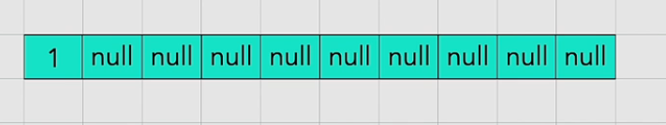

Upon adding 10 elements

1. Insertion algorithm in linked list

